GOVERNMENT DEGREE COLEGE FOR WOMEN
BAPATLA, GUNTUR Dt.

Dr. G. SESHU

PERSONAL PROFILE

- Name: Dr. G.SESHU
- Designation: Lecturer
- Subject: English
- Name & Address of the College: Government Degree College for Women,
Bapatla, Guntur District, Andhra Pradesh.

- Mobile No.: 9989544789
- E-Mail Id: seshugomati@gmail.com
- Year of Joining Service:
- As Junior Lecturer – 19-01-2002
- As Degree Lecturer –13-05-2013

- Experience as Lecturer (Degree) – 5 yrs. & 9 months
- Qualification/s: M.A. (English), AP SET &PhD.
- Works shops/Refresher/Orientation Course/s Attended/Done (till date):

- Orientation Course: HCU, Hyderabad – 2014
- Five Days Orientation Program, from 24th to 28th June, 2014 by ANU at TJPS.
- Two Days Zonal Level Workshop, 17th& 18th December, 2014, by Govt. College for Women (Autonomous).
- Three days Workshop from 29th July – 8th August, 2015 by
- CCE in association with RUSA & Regional English Language Office, US Embassy.
- One-Week National Workshop – JMJ College for Women, Tenali – from 01-11-2016 to 07-11-2016 – “Emerging Trends & Challenges to Enhance Quality in Higher Education.”
- Two Day National Workshop, 10th& 11th November, 2016 at SPMVV.
- One-Day National Workshop, 25th November, 2017, by KBN College (Autonomous).
- Refresher Course: ARPIT Online Refresher Course in English Language Teaching on 30.03.2019 (from Nov. 2018 to Feb. 2019).
- One Day Workshop on NIRF Ranking on 17.10.2019.
- One-Week Faculty Development Programme on “Recent Trends in Teaching Learning Methodologies Using ICT in Higher Education Institutions from 24.10.2019 to 30.10.2019.

- Conferences/Seminars Presented/Participated (till date):

- Paper presented at PVP Siddhartha Institute of Technology in Two Days International Multidisciplinary Conference, 30th& 31st, March, 2018.
- Paper presented at ANU in Two Days National Seminar 28th& 29th March 2018.
- Paper presented at P R Govt. College (A), Kakinada in Two Days National Seminar on 22nd& 23rd February 2019.

- Paper/s Published in Journals (till date):
- Paper/s Published in Journals (till date):
- Research journal of English Language and Literature (RJELAL), Vol. 3.3.2015 (July-Sep).
- New Academia: An International Journal of English Language, Literature & Literary Theory, UGC Journal No. 44829, Vol. VII, Issue II, April, 2018.
- Muse India: the literary ejournal, UGC Journal No. 41275, Issue 79 (May-June 2018).
- Sambodhi: ISSN No. 2249-6661, Volume 44, Issue (01) VI, January-March 2021, Literature the Marginalised: A Select Study of Narayan’s Kocharethi and Kavery Nambisan’s Scent of Pepper.

- Online Courses
- Six-Week Online Course ((12 Hours) by British Council – Issued 2nd August, 2015 – “Exploring English: Language and Culture.”
- July to September 2015 (20 Hours) by NPTEL, IIT Kanpur, “Practical English: Learning and Teaching.”
- NPTEL Online Course – Swayam – Short Fiction in Indian Literature – July-Oct 2019 – 12 weeks
- Teaching Effectively on Online – Three Week Online Course – July 22nd to August 6th , 2020.

- Innovations in Teaching & Learning:
- College Magazine
- Student Out-Reach Programme
- Participation of Students in National Seminar

- Short Term Courses/FDP/ToT attended/ToT as a Resource Person 2020

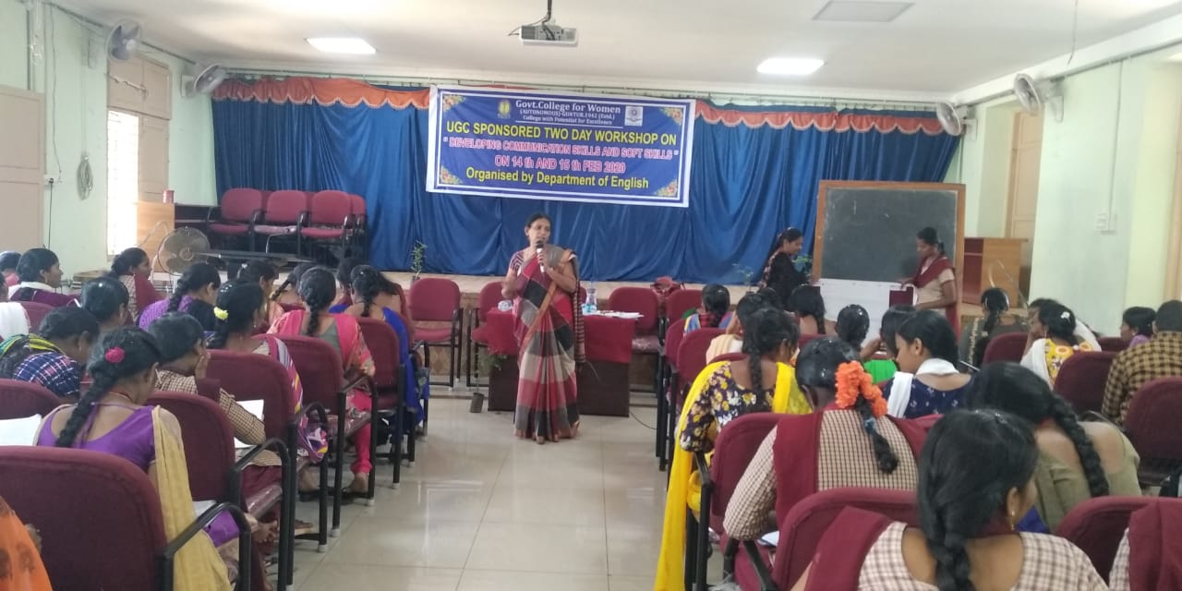

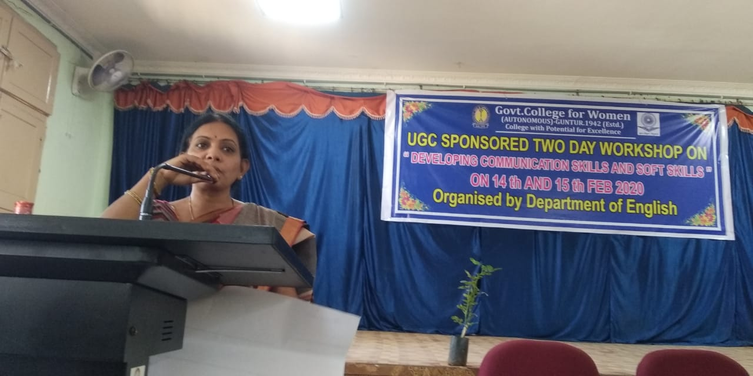

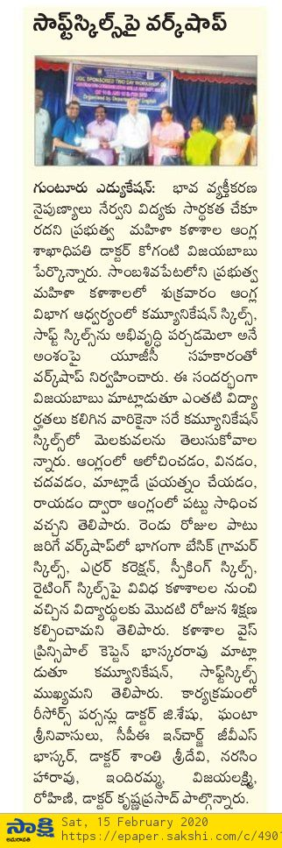
Resource Person - attach the letters and other documents received
FDP - attach online and one week Course at Eluru

